Dated 11-02-2024

Bucket : Object .

Only one copy of an object with a same name .

Update in s3 as text.txt

If object is deleted means its permanently deleted there no way to restore.

There are diff interfaces to interact with AWS services.

1.Management console .( Web based interface)

2.CLI ( Command line interface) ( Cloudshell -Jump through Management Console )

3.SDK ( Software Development Kit)

4. API ( Application Programming interface)

All these interfaces are API only .

Now create the Bucket

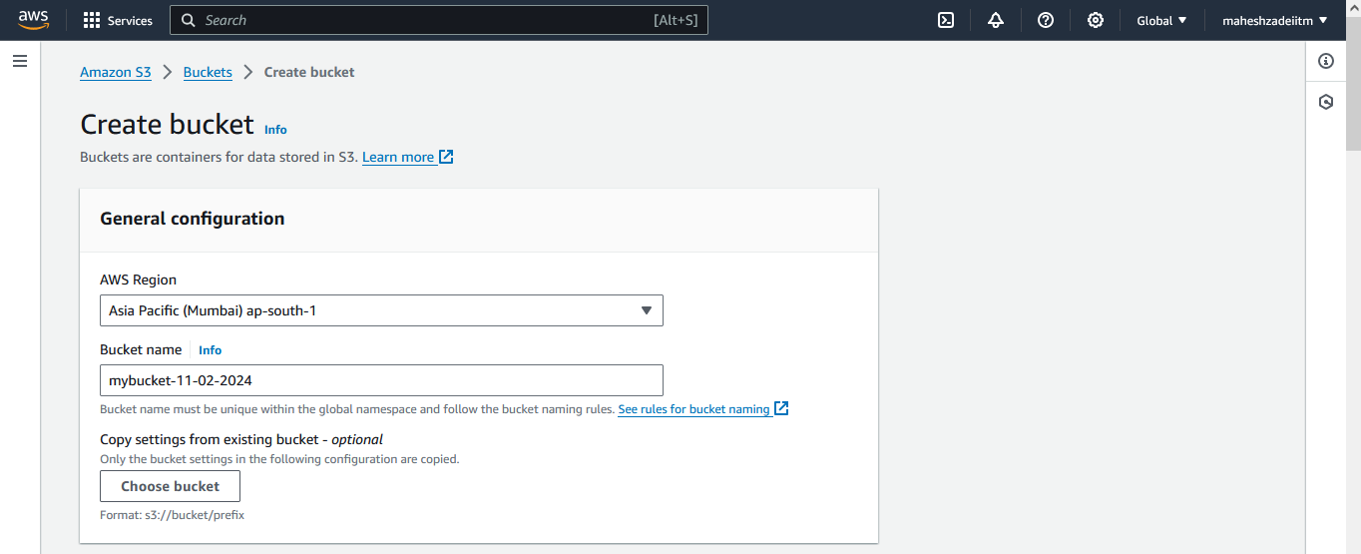

Disable Block all public access

Rest keep all the same and click on create bucket

Create the Dem test Txt file and upload in S3 Bucket

Create txt file

Copy this url in browser

We will get the error message

So now go to bucket policy

Go to permissions

Edit bucket policy

Open policy generator

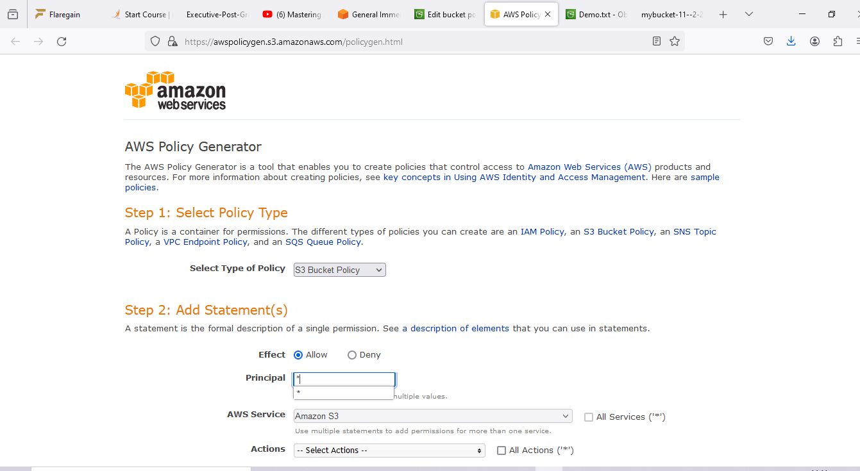

Copy ARN

Put /\* at the end of ARN

Click on generate policy

Copy the policy JSON Document

And paste in

{

"Id": "Policy1707641020927",

"Version": "2012-10-17",

"Statement": [

{

"Sid": "Stmt1707641002345",

"Action": [

"s3:GetObject"

],

"Effect": "Allow",

"Resource": "arn:aws:s3:::mybucket-11--2-204/\*",

"Principal": "\*"

}

]

}

And paste in policy editor in AWS Console

Then click on save changes

Successfully edited bucket policy

Check the DNS of the bucket URL again the browser

It will show the bucket Contents

Now edit the demo.txt file and add the contents

I want to update this file

Again go to object

Again upload the Demo.txt file

There is one copy of this file in the bucket

Now refre in broser and check the bucket DNS

<https://mybucket-11--2-204.s3.ap-south-1.amazonaws.com/Demo.txt>

This means one copy of a same name

It overwrite exiting one

Now perform a delete operation

Type permanently delete

Nothing preset in bucket

No scope to restore it back.

Now let’s see the concept of versioning.

Go to properties and click on versioning.

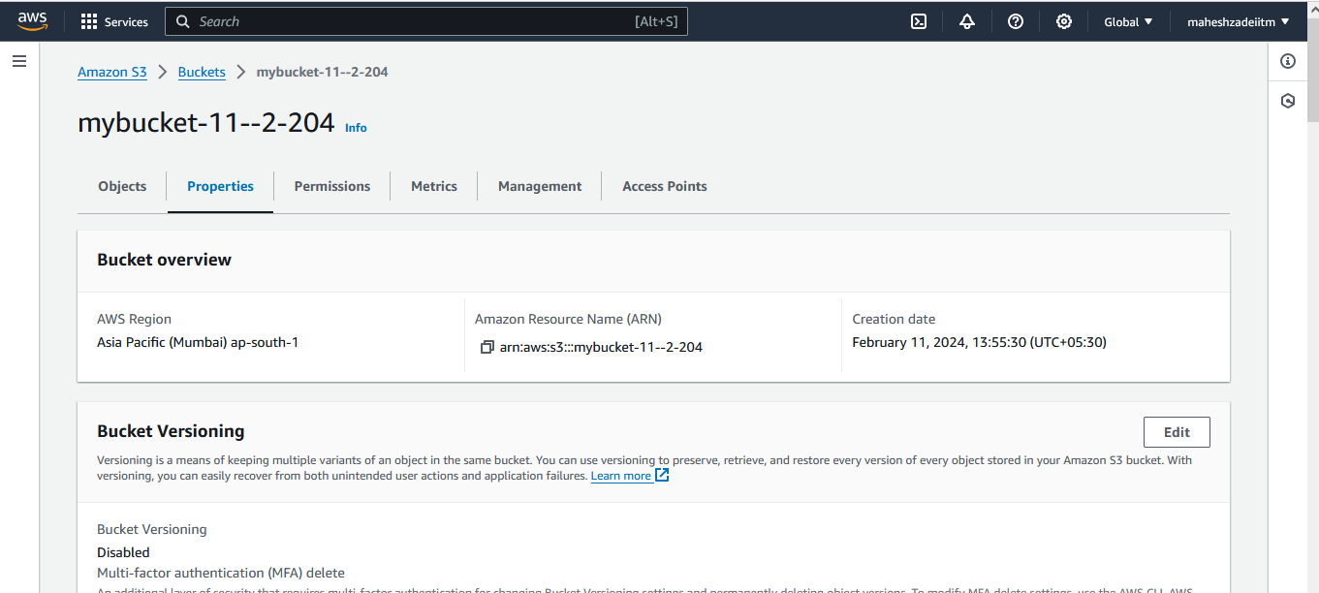

Edit bucket versioing

Go to edit and enable

And save changes

Go to object and it will show the show version button

Versioning button or Switch to enable or disable

Here we will the parent object

Now Click on CLI Icon

This button is known as Cloud shell icon

Open this clous shell in new tab

Click on Close

Create text file in cloushell by echo command

Below comand

echo "This is atext file of understanding concept of versioing" >> demoversioning-10.02.2024.txt

Now copy this file in s3 bucket

And command is

aws s3 cp demoversioning-10.02.2024.txt s3:// mybucket-11--2-204

command synatax

Pls end in Cloudshell now

Below command type

aws s3 cp demoversioning-10.02.2024.txt s3://mybucket-11--2-204

again go to bucket

and check bucket is available

Select this Bucket and copy the URL

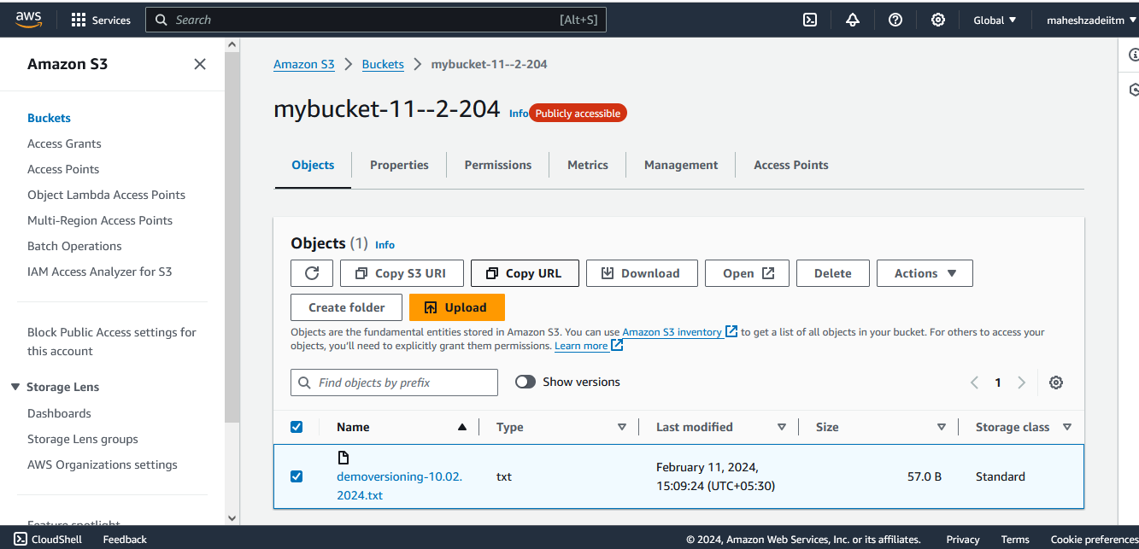

Paste the URL in browser

Now check the show version bitton

It will show version ID

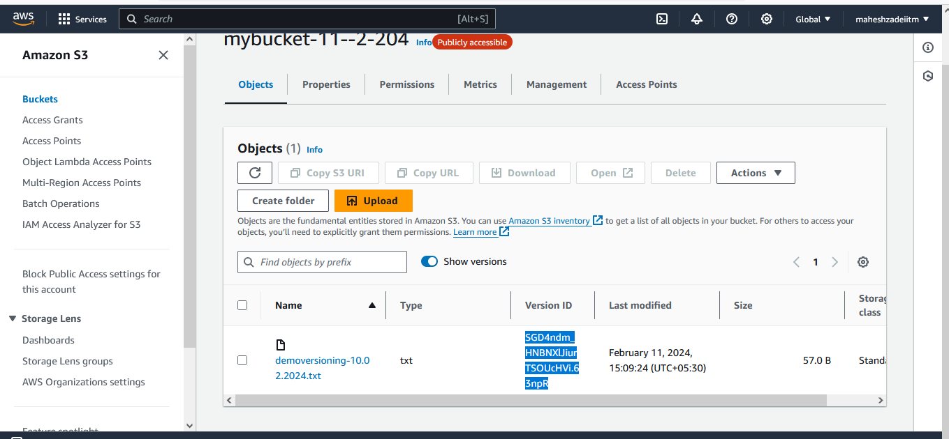

Now lest make the change in the bucket file

Command is

echo "Appending a new line for versioning of a file" >> demoversioning-10.02.2024.txt

again, use the AWS Command

aws s3 cp demoversioning-10.02.2024.txt s3://mybucket-11--2-204

Go back to object new versioing file created.

Copy the URL

URL of the version ID would be appended

Need to append a version ID

Edit bucket policy

Need to give get object version permission.

And save

Select s3 and then select get object version

Now refresh the page again and u will get the page

Deleting a object and deleting a object version is different

Deleting the object is undone

Deleting object version is cant be undone

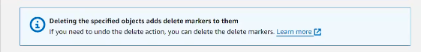

Add delete marker to protect shield.

Delete marker is keyword

Shield to protect my object version

We talked about

Versioning is done now